 | 15.1.1 Editors - Movie Clip Editor - Header Tools and Options
Table of content
Movie Clip Editor - Header 3
Movie Clip prop 3
List of clips in the scene 3
Search form 3
Clip Edit Box 3
Number of Fake Users 3
Fake User 3
Open 4
Remove 4
Info String 4
Pivot Point 4
Lock to Selection 4
Mask Display 5
Mask Display 5
Spline 5
Edge Display 5
Overlay 5
Overlay Mode 5
Clip Display 5
Clip Display 5
R G B 5
BW 5
Mute Footage 5
Render Undistorted 5
Show Metadata 6
Show Stable 6
Grid 6
Calibration 6
Display Aspect Ratio X Y 6
Marker Display 6
Pattern 6
Search 6
Path 6
Length 6
Show Disabled 6
Info 6
3D Markers 6
Display Thin 6
Mask Display 7
Mask Display 7
Spline 7
Edge Display Type 7
Outline 7
Dash 7
Black 7
White 7
Overlay 7
Overlay Mode 7
Alpha Channel 7
Combined 7
Blending Factor 7
Marker Tools 8
Refine Markers Backwards 8
Clear Track Path Backwards 8
Track Markers Backwards 8
Track Markers Sequence Backwards 8
Track Markers Sequence Forwards 8
Track Markers Forwards 8
Clear Track Path Forwards 8
Refine Markers Forwards 8
Graph editor Options 8
Only selected 8
Display Hidden 9
Show Frames 9
Show Track Motion 9
Show Tracks Error 9
Options panel 9
Show Seconds 9
Sync Visible Range 9
Dopesheet editor Options 9
Only selected 9
Display Hidden 9
Dope sheet Sort Field 9
Invert 9
Options panel 10
Show Seconds 10
Sync Visible Range 10
Proportional Editing 10
Proportional Editing 10
Settings 10
Mask Prop 10
Mask Prop 10
List of Masks 11
Mask Edit Box 11
Fake User 11
Search form 11
Mask Display 11
Mask Display 11
Smooth 11
Overlay 11
Edge Display Type 11
Gizmo 12
Show Gizmo 12
Viewport Gizmos 12
Navigate 12

Movie Clip Editor - Header

The Movie Clip Editor has two modes, and is three editors in one. So we have to explain the single header tools and options at a one by one base.

Movie Clip prop

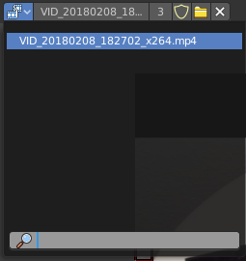
Available in Tracking in Clip mode and Mask mode.
This property contains the list of loaded movie clips. When no movie clip is loaded or active, then it displays the Open Buttons. When a movie clip is loaded and active, then it displays the name of the currently active movie clip.

From left to right ...

List of clips in the scene
This is a list of the movie clips in the scene. Allows you to witch to other images.

Search form
Search for specific clips.

Clip Edit Box
The name of the currently selected movie clip. You can rename the movie clip here too.

Number of Fake Users
In case this file has a fake user assigned, then this number displays the number of fake users.

Fake User
With this button you assign a fake user to this selected image.
Data, like images, that is not longer linked to anything else gets removed when you save and reload a scene. Bforartists has the concept of fake users to go around this behavior. An image with a fake user is in fact linked to something. And so it is not lost when you save and reload the scene.

Open
Open a new movie clip.

Remove
Removes the movie clip. Note that it will not be removed when it has a fake user assigned. Then the clip becomes simply inactive. You can still use it from the list again.

Info String

Available in Tracking in Clip mode.
A string, giving you some informations about the scene. In this case the number of solve errors for the current tracking.

Pivot Point
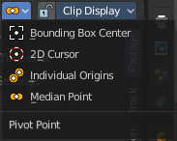
Available in Tracking in Clip mode and Mask mode.
Adjust the pivot point for transform operations. The names should be self explaining.

Lock to Selection

Available in Tracking in Clip mode.
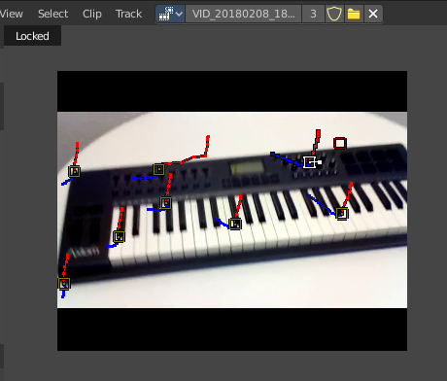
With lock to selection disabled the viewport stands still and the markers moves. With lock to selection enabled the view is centered at the current selected marker, and the video moves around.

Available in Tracking in Clip mode and Mask mode.

Mask Display
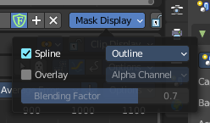
Available in Mask mode.

These are display options for mask overlays.

Mask Display

Spline
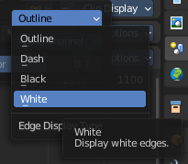
Display spline overlays.

Edge Display
Changes the spline overlay to outline, dash, black or white edges.

Overlay
Displays an overlay overlays.

Overlay Mode
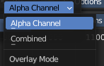
Show combined color channels or alpha channel. When using combined, the Blending Factor slider can be changed.

Clip Display

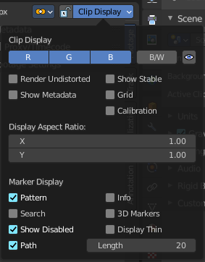
Available in Tracking in Clip mode and Mask mode.

Display options for the tracking footage.

Clip Display

R G B
Display the red green and blue channels of the footage

BW
Display the footage in black and white.

Mute Footage
Hide the footage.

Render Undistorted
Render Preview undistorted.

Show Metadata
Shows the metadata of the clip if available.

Show Stable
Show stable footage in editor. Stabilization needs to be enabled.

Grid
Displays a red grid over the footage that displays the lens distortion.

Calibration
Use manual calibration helpers.

Display Aspect Ratio X Y
The aspect ratio to display the footage.

Marker Display

Pattern
Displays the rectangles around the markers.

Search
Shows a search bound box around the currently selected marker.

Path
Shows the paths for the markers.

Length
How much of the path is displayed before and after the current position in the movie clip.

Show Disabled
Show also disabled markers.

Info
Displays an information string at the currently selected markers.

3D Markers
Displays a green dot at the center of the marker.

Display Thin
Displays the markers, marker widgets and marker lines with thin lines.

Mask Display
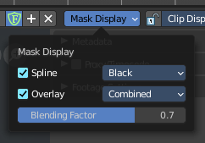
Available in Tracking in the Mask mode.

Mask Display

Spline
Show splines in as a mask overlay

Edge Display Type
A drop down that shows the different spline mask overlay types.

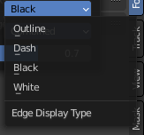
Outline
Display white edges with a black outline.

Dash
Display dashed black-white edges.

Black
Display black edges.

White
Display white edges.

Overlay
Show mask overlays.

Overlay Mode
A drop down that shows different mask overlay types.

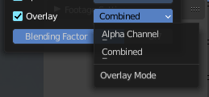
Alpha Channel
Show the alpha channel of the mask.

Combined
Show the combined space background of the image in the mask

Blending Factor
When combined is activated, you can control the overlay blending factor of rasterized masks.

Marker Tools
Available in Tracking mode in Graph and Dope sheet mode.

Tools to refine and modify the markers.

Refine Markers Backwards
Refine selected markers position by running the tracker from tracks reference to current frame.

Clear Track Path Backwards
Clear tracks before the current position.

Track Markers Backwards
Track selected markers backwards.

Track Markers Sequence Backwards
Track selected marker sequence backwards.

Track Markers Sequence Forwards
Track selected marker sequence forwards.

Track Markers Forwards
Track selected markers forwards.

Clear Track Path Forwards
Clear tracks after the current position.

Refine Markers Forwards
Refine selected markers position by running the tracker from tracks reference to current frame.

Graph editor Options

Only selected
Only display channels relating to the current objects and data.

Display Hidden
Display also channels from objects/bones that are not visible.

Show Frames
Show curve for per frame average error. Camera motion should be solved first.

Show Track Motion
Display the speed curves for the selected tracks. Red is X direction. Green is Y direction.

Show Tracks Error
Display the reprojection error curve for the selected tracks.

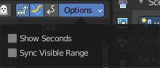
Options panel

Show Seconds
Option. Display the timeline numbering in seconds instead of frames.

Sync Visible Range
Option. Synchronize the visible timeline range with other time based editors.

Dopesheet editor Options

Only selected
Only display channels relating to the current objects and data.

Display Hidden
Display also channels from objects/bones that are not visible.

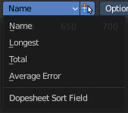
Dope sheet Sort Field
Sort the list of the tracks by chosen method.

Invert
Invert the sort order of dope sheet channels.

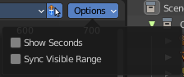
Options panel

Show Seconds
Option. Display the timeline numbering in seconds instead of frames.

Sync Visible Range
Option. Synchronize the visible timeline range with other time based editors.

Proportional Editing

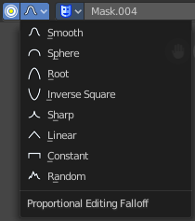
Proportional Editing
Enables proportional editing.
Proportional Editing is a way of transforming selected elements (such as vertices, or in this case the handlers for the mask spline curves) while having that transformation affect other nearby elements with a falloff. For example, moving a single vertex will move unselected vertices within a given range. And the falloff means that selected vertices that are closer to the selected vertex will move more than those farther from it.

Settings
Choose between different falloff methods for the proportional editing. The settings are hidden when you have proportional editing off.

Mask Prop

Mask Prop
When you are in Mask mode then you can create a new mask, and work with this mask then.
Masks have many purposes. They can be used to mask out, or influence a particular object in the footage in Motion tracking. They can be used for manual rotoscoping to pull a particular object out of the footage. They can be used as a rough matte for green-screen keying.
Masks are independent from a particular image of movie clip, and so they can also be used for creating motion graphics or other effects in the compositor.
Masks can be driven over the time so that they follow some object from the footage. For example a running actor. This can be achieved with shape keys or parenting the mask to tracking markers.

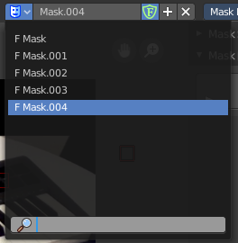
List of Masks
This is a list of the masks in the scene. Allows you to switch to other masks.

Mask Edit Box
The name of the currently selected mask. And you can rename the image mask too.

Fake User
Wit this button you assign a fake user to this selected mask. Masks gets created with a fake user already. Means when you save the scene and reopen it, then this mask will still be there.
Data, like images, that is not longer linked to anything else gets removed when you save and reload a scene. Bforartists has the concept of fake users to go around this behavior. An image with a fake user is in fact linked to something. And so it is not lost when you save and reload the scene.

Search form
Search for specific masks.

Mask Display

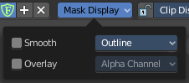
Mask Display
In Mask mode and with a Render result. Adjust the display of the mask.

Smooth
Smoothens the outline of the mask curve.

Overlay
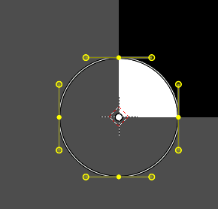
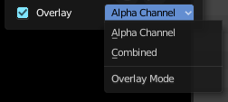
When it's a closed curve then this closed area gets displayed as filled where it covers the image. When you tick Overlay then a second drop down box becomes active.

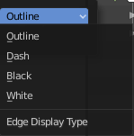
Edge Display Type
The mask curve can be displayed in different styles.

Gizmo

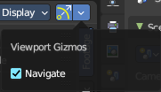
Show Gizmo
Show or hide all gizmos in the editor.

Viewport Gizmos

Navigate
Show or hide the Navigate Gizmo.

